**OPINION**

**MBTA retirement fund is headed for a financial reckoning**

The T retirement fund’s financial outlook is even worse than it appears.

**By Mark T. Williams and Charles Chieppo** Updated June 19, 2023, 3:00 a.m.

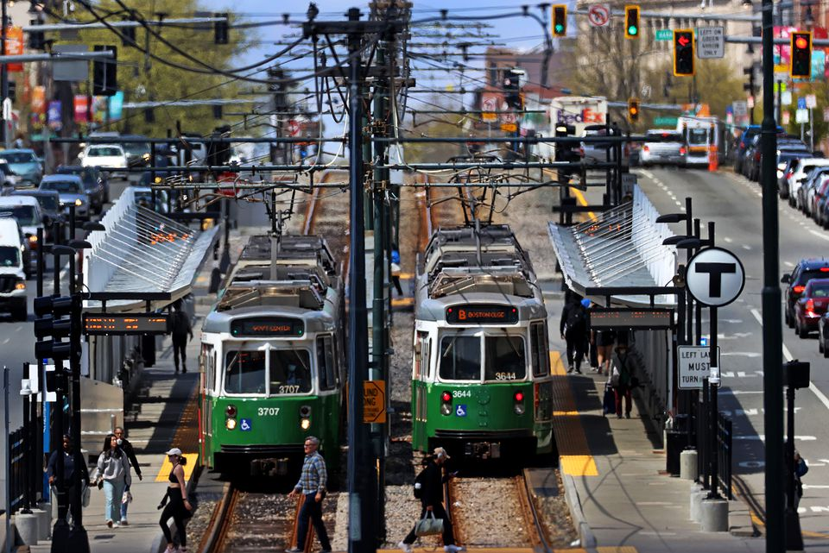MBTA's Green Line running along Commonwealth Avenue. DAVID L. RYAN/GLOBE STAFF

The MBTA Retirement Fund is going over a cliff, and the reasons why are well known. But neither the T nor its unions are in a hurry to do anything about it.

The new MBTA Retirement Fund Actuarial [Valuation Report](https://pioneerinstitute.org/wp-content/uploads/2022-Actuarial-Valuation-Report-Board-Approved.pdf) shows the fund’s balance as of Dec. 31, 2022, was $1.62 billion — about $300 million less than what it was just 12 months earlier. Its liability — the amount it will owe current and future T retirees — is over $3.1 billion, meaning the fund is about 51 percent funded. In 2006, it was 94 percent funded. A “death spiral” generally accelerates when retirement system funding dips below 50 percent.

In April, the Pioneer Public Interest Law Center got the MBTA to hand over an August 2022 arbitration decision regarding a pension dispute between the T and its biggest union. It contained a critical win for the authority: Arbitrator Elizabeth Neumeier decided that most employees would have to work until age 65 to earn a full pension, saving the MBTA at least $12 million annually.

But the Carmen’s Union sued to invalidate that portion of the decision, and the parties returned to the bargaining table. The new pension agreement they hammered out doesn’t include the historic retirement age victory; T management negotiated it away.

The fund’s problem isn’t on the contribution side. In 2007, the T, which is responsible for three-quarters of any shortfall, contributed $37 million to the retirement fund. Sixteen years later, that annual contribution is well over $100 million.

As of Dec. 31, 2022, 5,555 active employees paid into the fund, but 6,783 retirees collected from it. The biggest reason for the mismatch is the age at which T employees retire. Those hired before December 2012 can retire with a full pension after 23 years of service, regardless of age. Those hired after December 2012 can retire with a full pension at age 55 after 25 years.

The arbitrator finally gave the MBTA the win it so desperately needed, and T management promptly gave it back. Many MBTA managers have long opposed changing the age at which employees can earn a full pension, fearing the reaction of T unions.

Another driver of the crisis is that T pension benefits are significantly more generous than what most other state employees get. For example, when a 60-year-old state employee earning $80,000 annually retires after 25 years, they get 1.5 percent of their salary for each year of service, or 37.5 percent, which adds up to an annual pension of around $30,000.

At the T, the multiplier is nearly 2.5 percent per year of service, so instead of receiving 37.5 percent, that same person’s pension benefit is 61.5 percent of their salary. At the T, the $80,000 earner will get nearly $50,000 annually.

T employees also contribute less toward their pensions than most state employees because, unlike state workers, T employee pension contributions are subject to collective bargaining rather than set by statute.

Another difference with the state is that the MBTA is part of Social Security. It’s one of a very small group of transit authorities created in the 1940s that pay both full Social Security and pension benefits. T retirees in their 60s are pulling down $50,000 to $60,000 annually from the pension, plus some $20,000 in Social Security. When the two are combined, it’s almost twice what most other state employees get. And even after paying into Social Security, total pension contributions for T workers aren’t much higher than what most state employees pay toward their pensions alone.

Hard as it may be to believe, the T retirement fund’s financial outlook is even worse than it appears. Financial projections assume the fund’s assets will earn 7.25 percent annually. Over time, actual returns have been more like 4 percent to 7 percent.

These misleading projections are based on other faulty assumptions. In her 2022 decision, Neumeier refused the MBTA’s request to use newer actuarial tables, ruling that changing would be costly and that there was no compelling reason to update the tables. The ones in place are from 1989 — so old that they assume all T employees are men. Since women tend to live longer, the tables materially understate the retirement fund liability.

The T’s retirement fund is headed for a financial reckoning. Doing nothing would leave two bad options — allowing the fund to default or saddling state taxpayers with a multi-billion-dollar bailout.

The MBTA couldn’t afford to give back its win on retirement age, and state policy makers can’t continue to ignore the fact that the MBTA Retirement fund is spiraling toward insolvency. The T and its unions clearly won’t fix the problem, so the governor and Legislature must step in to raise the retirement age at the MBTA and bring employee contributions and benefits in line with those that other public employees in Massachusetts receive.

*Mark T. Williams is a professor of finance at Boston University’s Questrom School of Business and president of the Boston Economic Club. Charles Chieppo is a senior fellow at Pioneer Institute.*